Digital Solutions Assessment 2022

FA3 – Assessment Task

Ciaran Fairbairn

North Lakes State College

Contents

Part 1: Research and Investigation 1

Mind Map 1

Existing Solutions 1

M.O.S.C.O.W. 2

Data Flow Diagram 2

Database/ER 3

Part 2: Coding & Testing 3

UI/Wireframe 3

User Persona/Use Cases 3

Evaluate-Test 3

# Part 1: Research and Investigation

What is Data?

Data is a collection of facts that can be used for a variety of purposes. Such as the length and width of a product, or the age and interests of a user. This data is collected and sent to a database which is a collection of data.

What Are Data Driven Systems & Solutions?

A data driven system and/or application is a specialised software for acquiring, managing, and presenting information. An example of this would be a ticket booking website, which collects data, manages it, verifies it, and then presents it to the user.

## Mind Map

Creating Ideas – Made by Miro.com

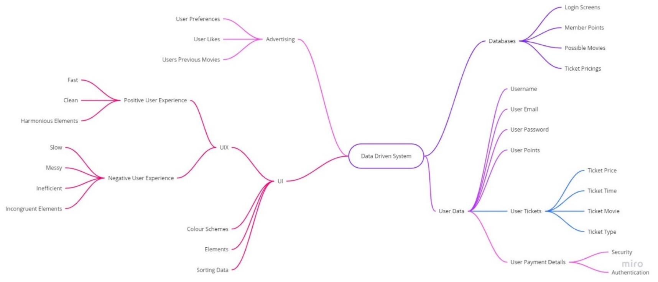

## Existing Solutions

Exploring Ideas

As an example of a data driven system used for movie cinemas is Event Cinema’s website, which can sell tickets, display tickets, display movie times and seat locations, movie genres, whether or not these movies are sold out and lastly the rating of the movie.

Each element are four sections, the Visual Hierarchy and scale is separated so that the most important segments of information are the largest thing on the screen (that being the time and ticket type of the movie), with the key for the information being slightly smaller than that and the menu being the smallest at the top. Each of these elements with a similar font and colour scheme, creating harmony. The shape of each element is rectangular to further create this sense of harmony.

The sectioned elements help prevent the user from being overwhelmed with information while the harmony of each element makes it pleasing to receive this information which is an important thing to note. This does not mean that Event Cinemas gets everything right.

There is a lot of wasted space in between each element, this is especially seen between the ‘Sort By’ and ‘Movie Title’ elements. Which is just a large section of blank space. Their menu at the very top is small and difficult to read, while also being cluttered. Comparing the Event Cinema’s website with the HOYTS website shows a clear difference between the two. Hoyts has an inconsistent colour scheme, which is brightly coloured and straining on the eyes which makes it much more difficult to understand the information being given. The Advertisements on the side only serve to take up space and distract the viewer from the given information about the tickets being sold. The scrolling on the UI is inconsistent and frustratingly jittery, making it difficult to read. There are too many tabs, making it difficult to understand whether or not the movie you are looking at is currently showing or an advance screening.

## M.O.S.C.O.W.

|  |  |  |
| --- | --- | --- |
| Must: | Should: | Won’t: |
| Hold User Information | Keep User Data Secure | Do anything else |
| Display Payment Information | Have a consistent colour scheme/element | Steal your card information (maybe) |
| Allow Users to Purchase Tickets | Display Movie Posters | Sell you crypto |
| Allow Users to Create Accounts | Have an Understandable Tab System | Install a bitcoin miner onto your computer |
| Display Movies | Have one time use payment checkbox | Have incongruent colour schemes |
| Display Available Seats | Send ticket to separate emails | Be cluttered with ads |
| Display Theatre Location |  | Have a difficult to understand navigational menu |

MOSCOW Criteria

The “Must” column contains all the things that are required to make the website functional, meaning all the things it must do in order to sell functioning tickets to the customer. The “Should” column contains all the things that would make this website better than the competition. Things that have been gathered from the existing solutions area. And the “Won’t” column contains unnecessary things that the website shouldn’t have. Things that would make the website worse than the competition.

The website MUST be able to hold and display user information or else it will not be functional; you cannot purchase a ticket if you can’t create an account or enter in your payment details. You can’t purchase a ticket if you don’t know what movies or seats are available. These are all completely necessary to having a functional website. If these things are not there, the customers will not be able to use the website and it would not be worth making or using.

The website SHOULD be able to keep the user’s data secure from possible malicious users, their private details such as names, email addresses, payment details or passwords. This website should also be able to display the posters for each movie, that way there is a visual representation of the movie which will help the user in navigating the menu, bringing us to the third thing the website should have; a navigable tab system. It is very important for users to be able to reach the pages they need to, or else the website becomes frustrating to use. A ticket selling website should be able to give those tickets to its users, so it will display it on the website and send it via email.

The website should NOT have cluttering ads that distract from the websites main use, selling tickets, or an incongruent or bright colour scheme which will distract from the movie posters or navigational menu.

## Data Flow Diagram

Showcasing the Flow of Data

If a user creates an account, they will send the details to a process which will then validate them after accepting them or deny them if they are invalid. (Invalid is a variety of things, from being taken already to being inappropriate.) Once the details have been accepted, they will be stored into the ***Users*** database. This database will then be called upon if the user is signing in again or is altering their password or username.

If the user wishes to purchase a ticket, they will need to insert payment details. These details will be sent to a process which will check if they are valid. If these details are valid, they will be stored in the ***Pay Details*** database which shares a primary key with the ***Users*** database.

Once a user decides to book tickets to a movie, they will press a button on the selected movie that will present the purchase verification page, and if they verify, they would like to purchase that ticket their payment details will be accessed, a ticket will be generated and then stored in the ***Tickets*** database so there cannot be any duplicates.

## Diagram Description automatically generatedDatabase/ER

Entity Relationship Diagrams

The cinema database will have a cinema key, name, and location. Each cinema will have one schedule, and a schedule can only have one cinema. A schedule will have its respective key, movie key, time, and run-time. This way a schedule has only the important information, and the movie key means that all the movie details are in a separate database. A schedule can have multiple movies, and a movie can have multiple schedules for different cinemas. A movie consists of its key, its name, the cinema key, and the rating.

Each movie has tickets, but every ticket only has one movie. A ticket consists of the tickets key, the user who owns its key, the movie key, the seat, and the time. Each user who purchases a ticket will have a previous viewings page where they can see past movies they have watched. This will consist of every key from every database but will only present the necessary information. Each user will have payment details to purchase a ticket. These details will consist of the user’s name, card number, CVV, address, expiration date and their user key as well as their own pay key.

Once a user registers an account, they will have generated a user key, a username and a password, and once they create a payment method, they will have a payment key.

# Part 2: Coding & Testing

## UI/Wireframe

User Interface Diagrams

## User Persona/Use Cases

Examples of use

(104-105 Dig Textbook)

## Evaluate-Test

Testing & Evaluation

|  |  |  |  |  |  |
| --- | --- | --- | --- | --- | --- |
| Test Case | Expected Outcome | Actual Outcome | Repeatable | Fixed | How |
|  |  |  |  |  |  |
|  |  |  |  |  |  |